*Project report submitted in partial fulfillment of the requirements for the award of the diploma of*

**DIPLOMA IN COMPUTER ENGINERING**

**Awarded By**

**STATE BOARD OF TECHNICAL EDUCATION AND TRAINING**

##### Submitted by

##### 1.K.V.V.D.PRAVEEN KUMAR (20252-CM-030)

##### 2 .M.SAI RAM (20252-CM-042)

##### 3.P.DURGA VARA PRASAD(20252-CM-054)

##### 4.Y.V.D.SAI (20252-CM-065)

##### 5.K.J.S.SAI (20252-CM-029)

Under the esteemed guidance of

**Mr. G L N V S KUMAR, MCA, Associate Professor**

**Ms. M LAKSHMI REKHA. MCA, Assistant Professor**

**Department of Computer Engineering**



**DEPARTMENT OF COMPUTER ENGINEERING**

**B.V.C. INSTITUTE OF TECHNOLOGY & SCIENCE**

**(Approved by A.I.C.T.E, New Delhi, Accredited by NAAC & Permanently Affiliated to S B T.E.T Vijayawada, certified by ODPL certification ISO 9001:2015 for Quality Management System)**

**AMALAPURAM - 533 201**

**2022**

**DEPARTMENT OF COMPUTER ENGINEERING**

**B.V.C. INSTITUTE OF TECHNOLOGY & SCIENCE**

**(Approved by A.I.C.T.E, New Delhi, Accredited by NAAC &Permanently Affiliated to S B T.E.T Vijayawada certified by ODPL certification ISO 9001:2015 for Quality Management System)**

**AMALAPURAM – 533 201**



**CERTIFICATE**

##### This is to certify that the project work on “BANKING SYSTEM” submitted by K.V.V.D.PRAVEEN KUMAR (20252-CM-030), P.DURGA VARA PRASAD(20252-CM-054), Y.V.D.SAI (20252-CM-065), K.J.S.SAI (20252-CM-029), .M.SAI RAM (20252-CM-042)is examined and adjudged as sufficient as a partial requirement for the Diploma In Computer Engineering at State Board Of Technical Education And Training, Vijayawada is a Benfield record of the work done by all under my guidance and supervision.

Internal Guide Head of the Department

Mr. G L N V KUMAR MCA, Mr. A.V.S.M. GANESH, MCA, M.Tech, MISTE.

Associate Professor, Associate Professor& Head

Department of Computer Applications. Department of Computer Applications.

#### PROJECT EXTERNAL EXAMINER

DISSERTATION CERTIFICATE

This is to certify that the dissertation entitled **“BANKING SYSTEM”** by K.V.V.D.PRAVEEN KUMAR (20252-CM-030), P.DURGA VARA PRASAD(20252-CM-054), Y.V.D.SAI (20252-CM-065), K.J.S.SAI (20252-CM-029), M.SAI RAM (20252-CM-042) students of **DIPLOMA IN COMPUTER ENGINERING** of **BVC Institute of Technology & Science, Amalapuram,** affiliated to **State Board Of Technical Education And Training, Vijayawada** is hereby accepted and approved as a credible work. It is further certified that this work has not been submitted for similar purpose anywhere else. There work has been found satisfactory for the partial fulfillment of the award of the Diploma of  **DCME.**

#### INTERNAL EXAMINER EXTERNAL EXAMINER

Head of the Department

**DEPARTMENT OF COMPUTER ENGINEERING**

##### BVC Institute of Technology &Science

**Amalapuram-533 201**

**DECLARATION BY THE CANDIDATE**

We, K.V.V.D.PRAVEEN KUMAR (20252-CM-030), P.DURGA VARA PRASAD(20252-CM-054), Y.V.D.SAI (20252-CM-065), K.J.S.SAI (20252-CM-029), M.SAI RAM (20252-CM-042) hereby declare that the project work entitled **“BANKING SYSTEM”** is an authenticated work carried out by us at B.V.C Institute of Technology and Science Amalapuram, under guidance of **Mr. G L N V S KUMAR and Ms M LAKSHMI REKHA** for the partial fulfillment of the award of the Diploma of **DCME** and this work has not been submitted for similar purpose anywhere else except to **BVC Institute of Technology &Science, Amalapuram** affiliated to **State Board Of Technical Education And Training, Vijayawada**

##### (Signature)

**Date: 1.** K.V.V.D.PRAVEEN KUMAR (20252-CM-030)

**2.** P.DURGA VARA PRASAD(20252-CM-054)

**3.** Y.V.D.SAI (20252-CM-065)

**Place:**  **4.** K.J.S.SAI (20252-CM-029)

##### 5. M.SAI RAM (20252-CM-042)

**ACKNOWLEDGEMENT**

I would like to express my heartiest concern of words to all those people who have helped me in various ways to complete my project.

My sincere thanks to respectable **Mr. G LN V S Kumar & Ms. M Lakshmi Rekha**, my internal guides. They been a constant source of encouragement and has inspired me in completing the project and helped me at various stages of project work.

My sincere thanks to respectable **Mr. A.V.S.M. GANESH,** MCA, M.Tech, MISTE, Associate Professor, and Head of the DCME, for his timely suggestions and co-operation for my project completion.

I would like to express my heartfelt gratitude to our Principal **Mr. B S S PHANISANKAR,** B.Tech, M.Tech, (Ph.D)., for forecasting an excellent academic environment and support.

I would like to extend my sincere thanks to all of our department faculty members, technicians and my family members for their help in completing the project.

**1.** K.V.V.D.PRAVEEN KUMAR (20252-CM-030)

**2.** P.DURGA VARA PRASAD (20252-CM-054)

**3.** Y.V.D.SAI (20252-CM-065)

**4.** K.J.S.SAI (20252-CM-029)

##### 5. M.SAI RAM (20252-CM-042)

.

**JSP BANKING SYSTEM**

**ABSTRACT**

**ABSTRACT**

The purpose of this project is in partial fulfilment of the requirements of customer using the Banking System for payment. The Design and development of this Bank Management system Provides a more secured approach in managing bank customer’s information which strengthens The relationships between banks and their customers by providing the right solutions that uses A multi-level security to improve customer satisfaction. The programming language used to Develop this project is php, html, css, bulma, bootstrap.

Banking System is one of the most important financial activities which will be carried out by any person who holds a bank account. There are various activities that can be carried out once you log in to your bank account. Once a user logs in he or she can check the bank balance, check bank account transaction history or account summary, add beneficiary accounts, transfer funds to another account, download account summary. Whenever we deal with a banking system main concern should be the security related to banking transactions and account login activity.

The Banking System as of now deals with a single sign-in log on and it will not be secure as expected. If a customer logs on from an unknown system outside the usual access device there are chances that it can be hacked easily and this might end up with a lot of issues. There are chances that if the user forgets the password and supposedly changes it and writes down the same somewhere and forgets to erase it or scramble it, there are chances that anyone can misuse the login. By using Banking System we can increase user privacy and safety of user account.

|  |  |  |
| --- | --- | --- |
| **TOPIC NO** | **TABLE OF CONTENTS**  **NAME OF THE TOPIC** | **PAGE NO** |

**CHAPTER – I INTRODUCTION**  4

**CHAPTER – II SYSTEM ANALYSIS AND DESCRIPTION**

* 1. EXISTING SYSTEM 5
     1. DISADVANTAGES OF EXISTING SYSTEM 5
  2. PROPOSED SYSTEM 6
     1. ADVANTAGES OF PROPOSED SYSTEM 6
  3. MODULES 7
  4. MODULE DESCRIPTION 8

SDLC MODEL 9

**CHAPTER – III REQUIRMENTS ANALYSIS**

* 1. HARDWARE REQUIRMENTS 11
  2. SOFTWARE REQUIRMENTS 11
  3. FUNCTIONAL REQUIRMENTS 11
  4. NON-FUNCTIONAL REQUIREMENTS 12

CHAPTER – IV SOFTWARE DESIGN

DATA FLOW DIAGRAMS 13

* + 1. SEQUENCE TABLES 15

SYSTEM ARCHITECTURE 16

UNIFIED MODELING LANGUAGE DIAGRAMS 18

CHAPTER – V IMPLEMENTATION

* 1. PHP TECHNOLOGY 26

CHAPTER – VI SYSTEM TESTING

* 1. INTRODUCTION 35
  2. TEST CASE 36

CHAPTER – VII SAMPLE SCREENS

SAMPLE SCREENS 37

CHAPTER – VIII CONCLUSION 46

CHAPTER – IX FUTURE ENHANCEMENTS 47

#### CHAPTER – X BIBILIOGRAPHY 48

**LIST OF FIGURES:**

|  |  |  |
| --- | --- | --- |
| **S.NO** | **NAME OF THE FIGURE** | **PAGENO** |
| 1 | SDLC Model | 9 |
| 2 | V-Model Design | 10 |
| 3 | Data Flow diagram | 13 |
| 4 | Sequence Tables | 15 |
| 5 | System architecture | 16 |
| 6 | UML modelling use case diagram | 18 |
| 7 | Class diagram | 20 |
| 8 | Sequence diagram | 21 |
| 9 | Activity diagram | 22 |
| 10 | Component diagram | 23 |
| 11 | Deployment diagram | 23 |
| 12 | Entity-relationship symbols | 24 |
| 13 | Entity-relationship diagram | 25 |
| 14 | Test case | 36 |
| 15 | Bank starting page | 37 |
| 16 | Bank home page | 37 |
| 17 | User sign-in page | 38 |
| 18 | User login page | 38 |
| 19 | User home page | 39 |
| 20 | User credit page | 39 |
| 21 | User debit page | 40 |
| 22 | User transfer page | 40 |
| 23 | Customer transfer page | 41 |
| 24 | User change/pin password page | 41 |
| 25 | Contacts us page | 42 |
| 26 | Admin sign-in page | 42 |
| 27 | Admin home page | 43 |
| 28 | Customer details | 43 |
| 29 | Customer permission page | 44 |
| 30 | Manage customer page | 44 |
| 31 | Check balance page | 45 |
| 32 | Deposit page | 45 |

# CHAPTER – 1 INTRODUCTION

**Banking** is defined as “Accepting of deposits of money from public for the purpose of Lending or Investment, repayable on demand or otherwise and withdrawable by cheque, draft, or otherwise”

**Banking** can be defined as the business activity of accepting and safeguarding money owned by other individuals and entities, and then lending out this money in order to earn a profit. However, with the passage of time, the activities covered by banking business have widened and now various other services are also offered by banks. The banking services these days include issuance of debit and credit cards, providing safe custody of valuable items, lockers, ATM services and online transfer of funds across the country / world .

Banking online means accessing your bank account and carrying out financial transactions through the internet on your smartphone, tablet or computer. It's quick, usually free and allows you to do tasks, such as paying bills and transferring money, without having to visit or call your bank.

Online banking, also known as internet banking, describes online systems that provide users access to their personal bank account information and functions, including but not limited to account transactions and balances

## CHAPTER – 2

**SYSTEM ANALYSIS AND DESCRIPTION**

#### EXISTING SYSTEM:

#### Early days Banks are managed manually. It required lot of time to record or to retrieve the details. The employees who have to record the details must perform their job very carefully. Even a small mistake would create a lot of problems. Report generations of all the information is very tough task. In Early bank system it have limited functionalities like accepting deposits, moneylending, money changing, and transferring funds etc. Maintenance of B catalogue and arrangement of the users details and transactions to the catalogue is very complex task. In addition to its maintenance of member details, transaction issue dates and return dates etc. manually is a complex task. All the operations must be performed in perfect manner for the maintenance of the Bank without any degradation which may finally result in the failure of the entire system

#### DISADVANTAGES OF EXISTING SYSTEM:

* + - * Security of information is very less.
      * Time taking process.
      * Maintain manually and visit physically.

#### 

#### PROPOSED SYSTEM:

#### 

#### Online Bank is proposed system. The users will register them through Online. Individually each member will have his account through which he can access then information he needs. Bank details like deposits, withdraws, number of transactions totally maintained by Banking system, present available cash, loan details, etc. all this information can be made handy. Regarding the users designation, number of transactions was issued. Transaction dates and loan issue dates and interests charged .If there is any delay in interest payment fine will imposed. Administrator can add, update the user details. Time consuming is low, gives accurate results, reliability can be improved with the help of security.

#### 2.2.1 ADVANTAGES OF PROPOSED SYSTEM:

* + - No need to visit physically.
    - Take less time.
    - Provide more security.

### 

### MODULES

### Administrative Modules

### Here in my project there are two types of modules. This module is the main module which performs all the main operations in the system. The major operations in the system are:

### 

### Admin Module

### Admin can access this project there is an authorization process. If you login as an Admin then you will be redirected to the Admin Home Page and if you are a simple user you will redirected to your Account Home Page. This performs the following functions:

### Create Individual Accounts, Manage existing accounts, View all transactions, Balance enquiry, Delete/close account etc.

### 

### * Admin login

### * Add/delete/update account

### * Withdrawal/deposit/statements transaction

### * Account Information

### * User details list

### * Active/Inactive account

### * View transaction histories

### User Module

### A simple user can access their account and can deposit/withdraw money from their account. User can also transfer money from their account to any other bank account. User can see their transaction report and balance enquiry too.

### 

### ¬ User login, use PIN system

### ¬ Creating/open new account registration

### ¬ Funds transfer (local/international/domestic)

### ¬ View statements transaction

### ¬ User account details

### ¬ Change Password and PIN

### 

### 

### MODULES DESCSRIPTION:

### The Modules description of Banking System project. These modules will be developed in PHP source code and MYSQL database.

### Create New Account: A customer who having the account in the world can create a virtual account through this module. This module receives the customer profile details and the bank account details with the proof of the ownership of the bank account.

### 2. Login: Virtual account holders can login in to the system using this module. Thus this is the secured login page for the customers in the website.

### 3. Virtual Account: After the approval of new virtual account creation, the customer assigned a unique virtual account number to make the online money transactions. This module views the details of the logged customer's virtual account.

### 4. Bank Accounts: A customer may have more than one bank account in various banks, in this case, the customer prompted to decide which bank account should reflect in the account debit or amount credit. For these operations customers can add their owned bank accounts here and it will be approved by the administrations of the system.

### 5. Fund Transfer: This is the module to make fund transfer to the virtual bank account holders or the usual bank account holders from the customer's specified bank account.

### 6. Beneficiary: Beneficiary is a person who receives money. Here the customer can add the beneficiaries to make fund transfer in the future.

### 7. Transactions: This module displays the transactions made by the customer in the particular date with the transaction details.

### 8. Administrative Control: This module contains the administrative functions such as view all virtual account, transactions, approve bank accounts, approve virtual accounts etc.

### There are other features and actions that can be performed on a back account but we are not going to look at bank accounts in their entirety only the basics, this way we avoid over complicating the exercise. The purpose of this whole exercise is to show the usefulness of object oriented programming as opposed to really wanting to create a banking system.

## SDLC MODEL:

#### DEFINITION:

SDLC is the process of following a software project within an organization. It consists of a detailed plan that describes how to develop, maintain, replace, modify, or improve specific software. The life cycle defines methodologies for improving software quality and the overall evolutionary process.

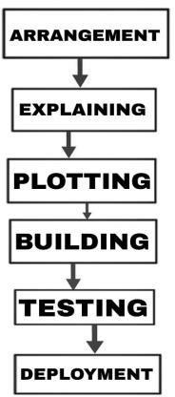

**Fig: 2.1 System Evolution Life Cycle Diagram**

## SDLC METHODS:

Various software evolution lifecycle models have been defined and designed to follow during the software evolution process. These models are also called "software evolution process models". Each process model carries out a series of steps specific to that type to ensure the success of the software evolution process. Following are the most important and popular SDLC models followed in the industry:

* + - Waterfall Method
    - Iterative Method
    - Spiral Method
    - V- Method

#### V-MODEL DESIGN:

Under The V Model is planned in parallel with the test phase corresponding to the evolution phase. So "V" has a validation phase on one side and a validation phase on the other side. The coding phase combines two aspects of a V Model.

The below figure illustrates the different phases in V-Model of SDLC:

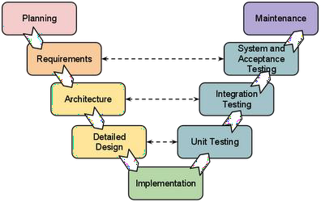

**Fig:2.2 V-model for SDLC**

#### CHAPTER 3 REQUIREMENT ANALYSIS

**HARDWARE REQUIREMENTS:**

* + - Processor : Intel Core Processor
    - Hard Disk : minimum 3GB for Database usage For future.
    - Memory : 1gb Ram or more.
    - Monitor : 15 VGA Colour.
    - Mouse : Logitech.

#### SOFTWARE REQUIREMENTS:

* + - Operating system : Windows Vista, Windows 7, Ubuntu.
    - Coding Language : PHP
    - A PHP engine : XAMPP-Windows
    - Data Base : MYSQL
    - A Web server : Apache HTTP server 2.2

#### FUNCTIONAL REQUIREMENTS:

* user id is provided user when they register
* The system must only allow user with valid id and password to enter the system
* The system performs authorization process which decides what user level can access to.
* The user must be able to logout after they finished using system.
* System must be able to verify information
* System must be able to delete information if information is wrong
* System must be able to search the database based on select search type
* System must be able to filter users and transactions based on keyword entered
* System must be able to show the filtered users and transactions in table view

#### NON-FUNCTIONAL REQUIREMENTS:

* Efficiency Requirement: When a Bank management system will be implemented administrator and user than admin will easily access user information as searching and user transaction will be very faster.
* Reliability Requirement: The system should accurately performs user registration ,user validation , report generation, money transaction and search

* Usability Requirement: The system is designed for a user friendly environment so that user and admin of bank can perform the various tasks easily and in an effective way.
* Implementation Requirements: In implementing whole system it uses html in front end with php as server side scripting language which will be used for database connectivity and the backend ie the database part is developed using mysql.

## CHAPTER – 4 SOFTWARE DESIGN

#### DESIGN OVERVIEW:

The design phase begins with the specification of the software requirements that you develop. Design is the first step towards the transition from the problem domain to the solution domain. Design is essentially a bridge between the final solution to meet the required specifications and requirements. It is the most critical factor affecting the quality of the software.

The design process for the software system has two levels.

1. System Design or Top level design
2. Detailed Design or Logical Design

#### DETAILED DESIGN:

In detailed design the interconnection of the modules or how the specifications of the modules can be satisfied is decided. Some properties for a software system design are

Verifiability Completeness Consistency Traceability

Simplicity/ Understandability

#### DATA FLOW DIAGRAMS:

The DFD gets a view of the system's input process output. That is, data objects flow into the software, and the resulting data objects transformed by the processing elements flow out of the software. Data objects represented by transformations with arrows on labels are represented by circles, also called bubbles. DFDs are displayed hierarchically. In other words, the first dataflow model represents the system as a whole.

#### DATA FLOW DIAGRAMS:

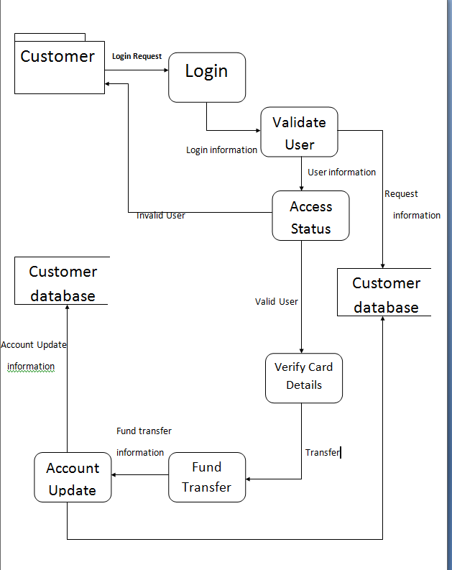

**Fig:4. 3DATA FLOW DIAGRAM**

#### 

#### SEQUENCE TABLES:

#### 4.1 CUSTOMER TABLE:

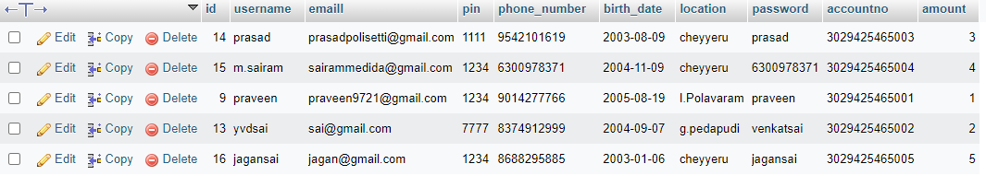

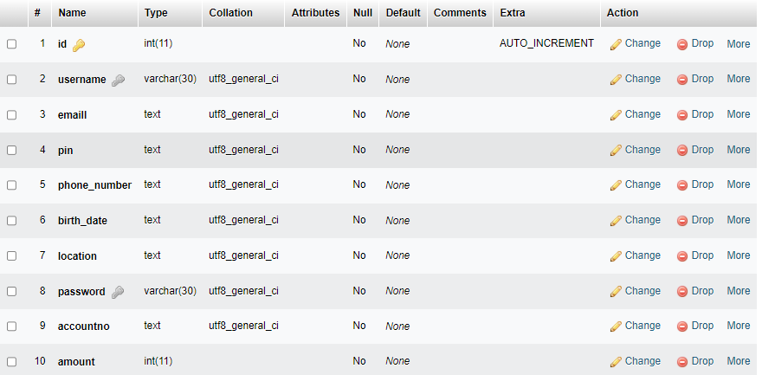

**4.2 ADMIN TABLE:**



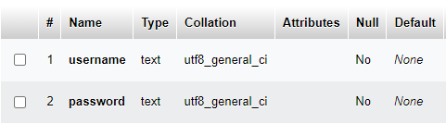

#### SYSTEM ARCHITECTURE:

A large amount of structured information is buried in unstructured text. The information extraction system extracts structured relationships in a document and enables sophisticated SQL-like queries in unstructured text. The information extraction system is incomplete and the output has incomplete accuracy and recall (that is, it contains false tuples and misses good tuples). In general, extraction systems have a set of parameters that can be used as "knobs" to adjust the system to precision or range. The choice of documents to process in the extraction system also affects the quality of the extracted relationships relation

.

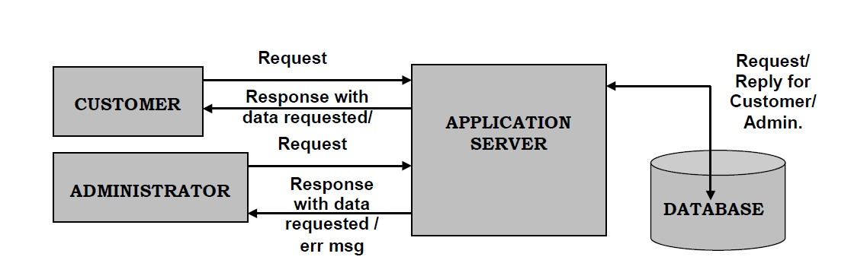

**Fig:4.4 SYSTEM ARCHITECTURE.**

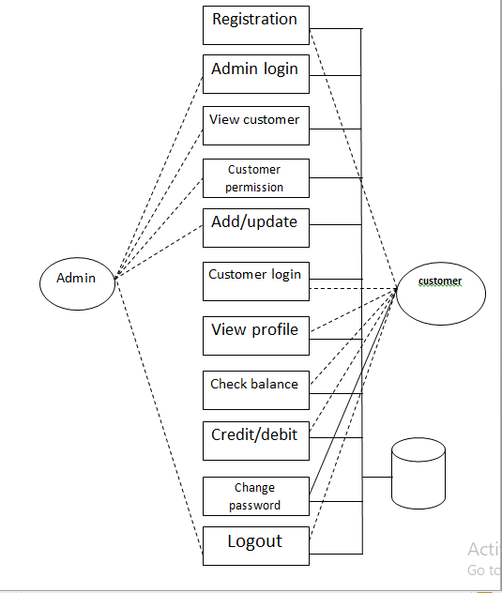

**Fig:4.5 SYSTEM ARCHITECTURE.**

#### 

#### UNIFIED MODELING LANGUAGE DIAGRAMS:

UML stands for Unified Modeling Language. UML is a standardized general-purpose modeling language in the field of object-oriented software engineering. This standard was created and maintained by the Object Management Group.

The goal is to become a common language for creating models of UML object-oriented computer software. The current format consists of two main components of UML metamodeling notation. Any form of method or process may be added in the future.

#### USE CASE DIAGRAM:

UML (Unified Modeling Language) use case diagrams are a type of behavior diagram defined and generated by use case analysis. Its purpose is to provide a graphic overview of the features provided by the system in terms of actors, goals (shown in use cases), and dependencies between these use cases. The main purpose of the use case diagram is to show what system functions are performed for what actors. You can explain the role of the actor in the system depicted.



**Fig:4.6 USE CASE DIGRAM**

#### 

#### CLASS DIAGRAM:

In software engineering, a UML (Unified Modeling Language) class diagram is a type of static structure diagram that describes the structure of a system by showing the relationships between the classes, attributes, operations (or methods) of the system and the system class. Indicates whether some classes contain information.



**Fig:4.7CLASSDIAGRAM**

**SEQUENCE DIAGRAM:**

A UML (Unified Modeling Language) sequence diagram is a kind of interaction diagram that shows how and in what order processes work with each other. This is the structure of the message sequence chart. Sequence diagrams are also known as event diagrams, event scenarios, and timing diagrams.



**Fig:4.8 SEQENCE DIAGRAM**

**ACTIVITY DIAGRAM:**

An activity diagram, when selected, is a graphical representation of the workflow of activities and actions for procedures that support repetition and concurrency. Activity diagrams in an integrated modeling language can be used to describe the business and operational step-by-step workflows of system components. The activity diagram shows the overall control flow control.



**Fig:4.9ACTIVITYDIGRAM**

#### COMPONENT DIAGRAM:

A component diagram shows a series of components and their relationships. A component diagram represents a static implementation view of a system. A component diagram contains a number of classes and interfaces. Contains a collection of graphic vertices and arcs.



**Fig:4.10 COMPNENT DIAGRAM**

#### DEPLOYMENT DIAGRAM:

The placement diagram contains the relationship with the node set. Here is an example of static deployment of the system. The distribution contains one or more components. A node is a physical element that exists at run time and represents a computational resource. Nodes are rendered in cubes.



**Fig:4.11 DEPLOYMENT DIAGRAM**

#### ENTITY-RELATIONSHIP DIAGRAM:

E-R (Entity-Relationship) Diagram is used to represents the relationship between entities in the table

The symbols used in E-R diagrams are:

**SYMBOL PURPOSE**

Represent Entity Sets.

RepresentRelationship

Represent Attribute

Line represents flow

Data Flow from Entity to Attribute

**Fig: 4.12 SYMBOLS FOR ENTITY-RELATIONSHIP DIAGRAMS**

#### ENTITY-RELATIONSHIP DIAGRAM:

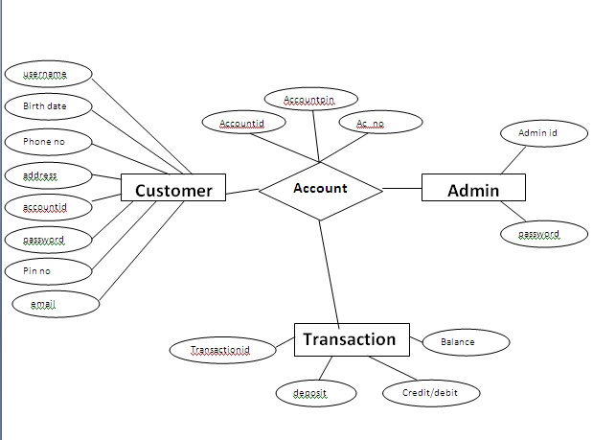

**Fig:4.13 ENTITY-RELATIONSHIP DIAGRAM**

#### CHAPTER – 5

#### IMPLEMENTATION

#### PHP TECHNOLOGY:

PHP started out as a small open source project that evolved as more and more people found out how useful it was. Rasmus Lerdorf unleashed the first version of PHP way back in 1994.

* PHP is a recursive acronym for "PHP: Hypertext Pre-processor".
* PHP is a server side scripting language that is embedded in HTML. It is used to manage dynamic content, databases, session tracking, even build entire e-commerce sites.
* It is integrated with a number of popular databases, including MySQL, PostgreSQL, Oracle, Sybase, Informix, and Microsoft SQL Server.
* PHP is pleasingly zippy in its execution, especially when compiled as an Apache module on the Unix side. The MySQL server, once started, executes even very complex queries with huge result sets in record-setting time.
* PHP supports a large number of major protocols such as POP3, IMAP, and LDAP. PHP4 added support for Java and distributed object architectures (COM and CORBA), making n-tier development a possibility for the first time.
* PHP is forgiving: PHP language tries to be as forgiving as possible.
* PHP Syntax is C-Like.

## Characteristics of PHP

Five important characteristics make PHP's practical nature possible −

* Simplicity
* Efficiency
* Security
* Flexibility
* Familiarity

#### HTML TECHNOLOGY:

Html (Hypertext Markup language) Is The Most Basic Building Block of The Web. It Define The Meaning And Structure Of Web Content .Other Technologies Besides Html Are Generally Used To Describe A Webpage.

It Can Be Assisted By Technologies Such Is Cascading Styles Sheets (Css) And Scripting Languages Such As JavaScript.

Html Is The Code Is Used Structure To A Webpage And Its Content The For Example Content Could Be Structure With In A Set Of paragraphs ,A List Of Bulleted Points, Or Using Images Data tables

## Characteristics of HTML:

* ‘USER FRIENDLY
* SIMPLE
* SEMANTIC STRUCTURE
* SEO(SEARCH OPTIMISATION)
* PLATFORM INDEPENDENT
* MEDIA SUPPORT

#### CSS TECHNOLOGY:

#### Cascading Styles Sheets (Css) Is Used To Style And Layout Webpages For Example To Alter The font, color, size And Space of Your Content, Split Into Multiple Columns ,Or Add Animations And Other Decorative Features

Css Is The Language For Describing The Presentation Of Web Pages, Including Colors, Layouts, And Fonts. It Allows One To Adapt The Presentation To Different Type Of Devices, Such As Large Screens, Small Screens Or Printers. Css Is Independent Of Html And Can Be Used With Any Xml-Base Markup Language

## Characteristics of CSS:

* PADDING
* FONT STYLE
* BACKGROUND
* FONTSIZE-ADJUST

#### JAVA TECHNOLOGY:

Java Script Is A High Level. Often Just In time Compiled language That Confirms To The E C M A- Script Standard. It Has Dynamic Typing. Prototype Object-Orientation and First- Class Functions. It Is Multi-Paradigm, Supporting Events-Driven ,Functional And Imperative Programming Styles

**MYSQL TECHNOLOGY:**

MySQL is an open-source relational database management system (RDBMS). Its name is a combination of “My”, the name of co-founder Michael Widenius’ daughter, and "SQL", the abbreviation for Structured Query Language. The MySQL development project has made its source code available under the terms of the GNU General Public License, as well as under a variety of proprietary agreements. MySQL was owned and sponsored by a single for-profit firm, the Swedish company MySQL AB, now owned by Oracle Corporation. For proprietary use, several paid editions are available, and offer additional functionality.

#### SAMPLE CODING:

* + 1. **ADMIN SAMPLE CODE:**

<?php

include "header.php";

include "adminsidebar.php";

?>

<!DOCTYPE html>

<html>

<head>

<meta name="viewport" content="width=device-width, initial-scale=1.0">

<link rel="stylesheet" href="adminhomestyle.css">

</head>

<body>

<div class="flex-container">

<div class="flex-item">

<h1 id="customer">

Welcome Admin !

</h1>

<p id="customer" style="max-width:800px">

From here you can manage all of core Internet Banking settings.

You can add/manage customers, view their transactions, edit their

details and even delete them. You can also post news on the website.

<br>Please keep in mind that with big power comes big responsibility.

Therefore please do not misuse your admin control to create trouble.

</p>

</div>

</div>

</body>

</html>

**header.php:**

@import url("fonts.css");

body {

margin: 0;

padding: 0;

background-color: #FAFAFA;

}

.flex-container-header {

display: -webkit-flex;

display: flex;

width: auto;

height: auto;

background-color: #263238;

}

.flex-item-header {

width: auto;

height: 100px;

margin: 10px;

}

h1 {

font-family: OpenSans-Light;

color: white;

font-size: 3rem;

line-height: 3rem;

margin-top: calc((1.5rem - 2rem) + 2.5rem);

margin-bottom: 1.5rem;

}

@media screen and (max-width: 855px) {

h1 {

font-size: 2.5rem;

line-height: 2.5rem;

margin-top: calc((1.5rem - 2rem) + 2rem);

margin-bottom: 1.5rem;

}

}

@media screen and (max-width: 510px) {

h1 {

font-size: 2rem;

line-height: 2rem;

margin-top: calc((1.5rem - 2rem) + 1.5rem);

margin-bottom: 1.5rem;

}

}

**adminsidebar.php:**

<html>

<head>

<meta charset="utf-8">

<title>Sidebar Menu with sub-menu | CodingNepal</title>

<link rel="stylesheet" href="style.css">

<script src="https://code.jquery.com/jquery-3.4.1.js">

</script>

<script src="https://kit.fontawesome.com/a876d05399.js">

</script>

</head>

<body>

<nav class="sidebar">

<div class="text">Admin Menu</div>

<ul>

<li><a href="adminhome.php">Home</a></li>

<li>

<a href="mycustomers.php" class="serv-btn">My Customers </a>

</li>

<li><a href="customerpermission.php">Customer Permission</a></li>

<li><a href="managecustomer.php">Manage Customers</a></li>

<li><a href="jsphome.php">Logout</a></li>

</ul>

</nav>

<script>

$('.feat-btn').click(function(){

$('nav ul'.feat-show').toggleclass("show");

});

$('.serv-btn').click(function(){

$('nav ul'.feat-show').toggleclass("show1");

});

</script>

</body>

</html>

#### Banking Database SAMPLE CODING:

<?php

$servername = "localhost";

// Enter your MySQL username below(default=root)

$username = "root";

// Enter your MySQL password below

$password = "";

$dbname = "banking";

// Create connection

$conn = new mysqli($servername, $username, $password, $dbname);

// Check connection

if ($conn->connect_error) {

header("location:connectionerror.php?error=$conn->connect_error");

die($conn->connect_error);

}

?>

# CHAPTER - 6 SYSTEM TESTING

### 

### INTRODUCTION:

The purpose of testing is to find errors. The outcome of a test task is the process of trying to discover all possible obstacles or weaknesses. This provides a way to verify the functionality of components, subassemblies, assemblies and/or finished products. This is the process of running software to ensure that it does not fail in an unacceptable way to meet the software system requirements and user expectations. There are many different types of tests. Each test type corresponds to a specific test requirement.

#### TEST CASE:

All the test cases mentioned above passed successfully. No defects encountered shown in Tab 6.1

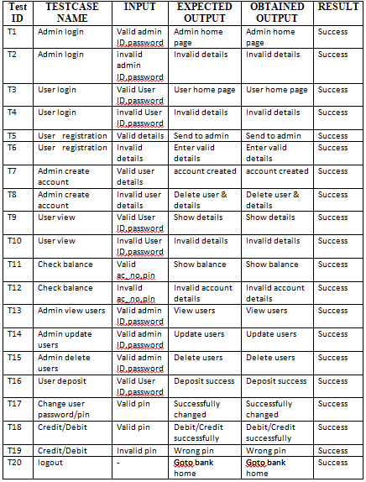

**Table: 6.1 Test Case Specifications**

# CHAPTER - 7 SAMPLE SCREENS

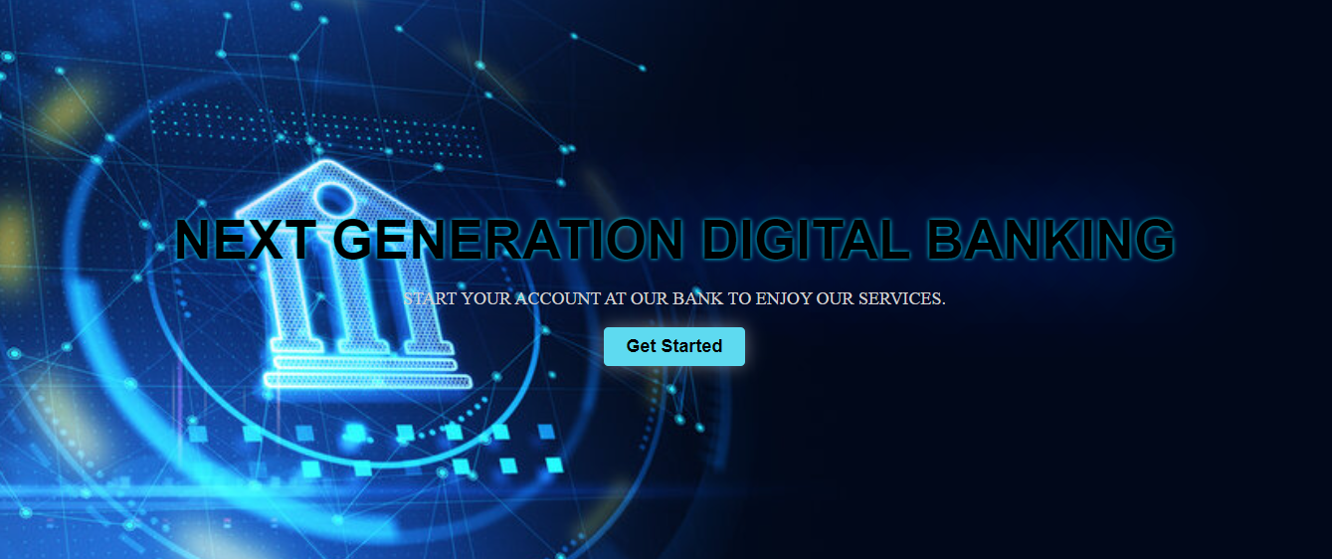

**7.1BANK STARTING PAGE**

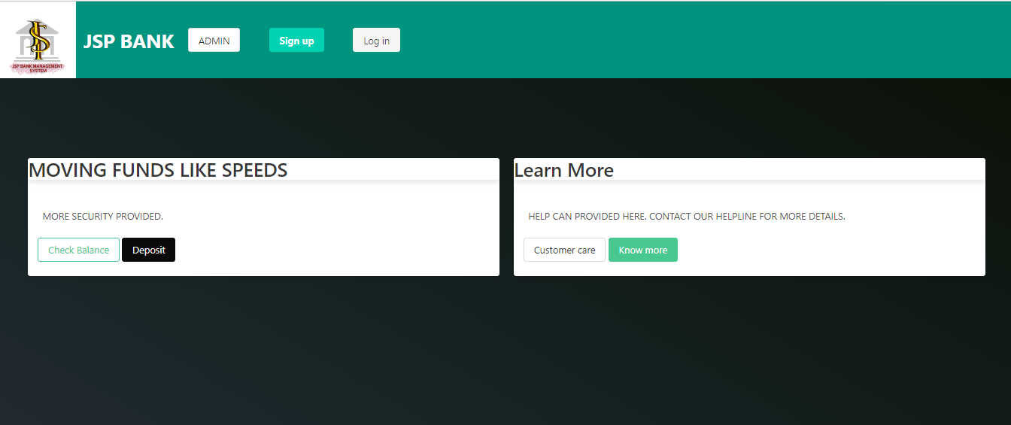

**7.3 BANK HOMEPAGE**

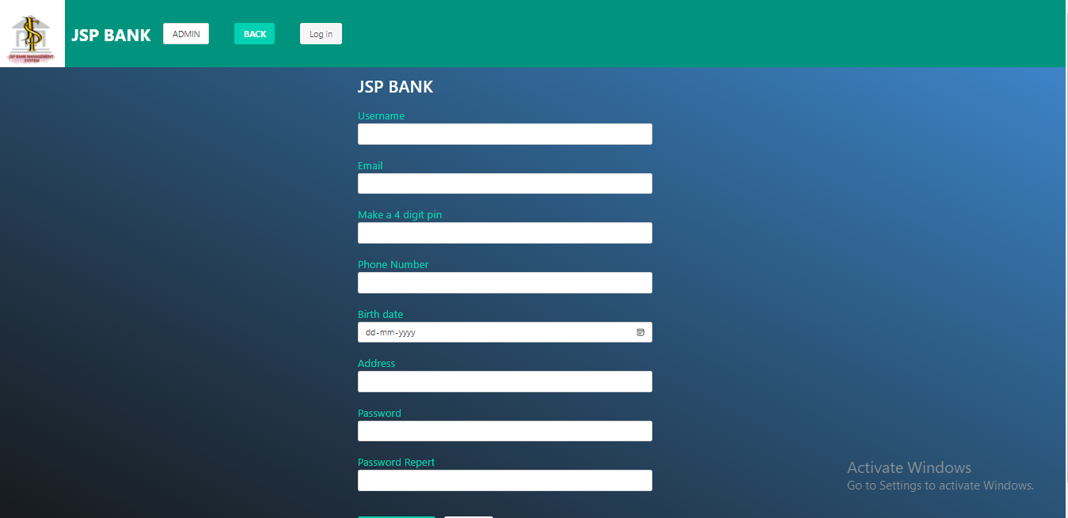

**7.2USER SIGN-IN PAGE**

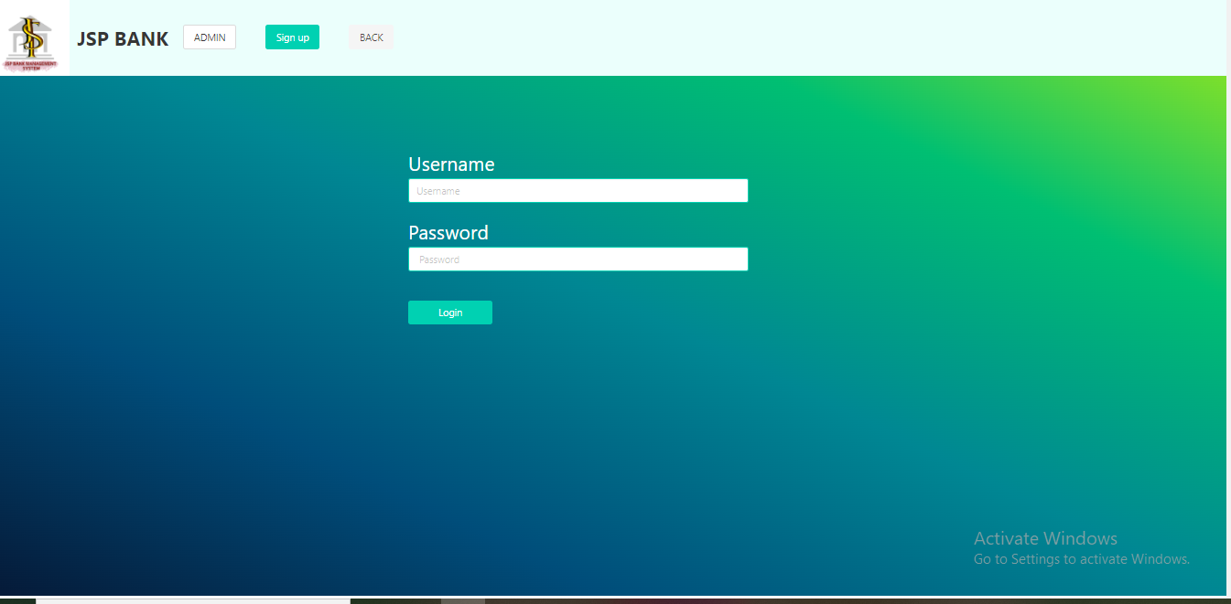

**7.4USER LOGIN PAGE**

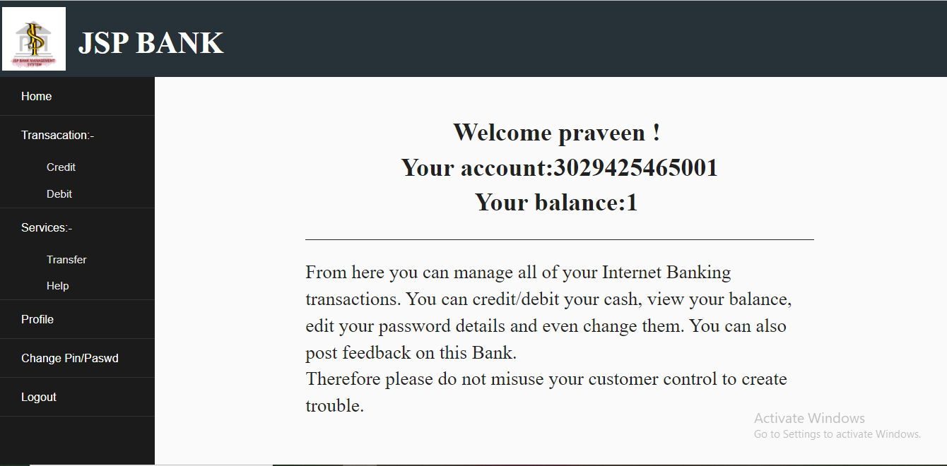

7.5 **USER HOME PAGE**

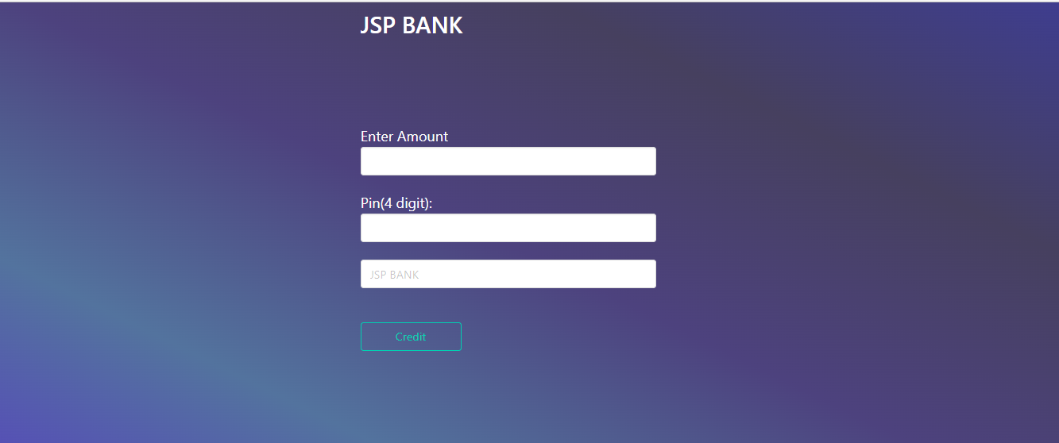

**7.7 USER CREDIT PAGE**

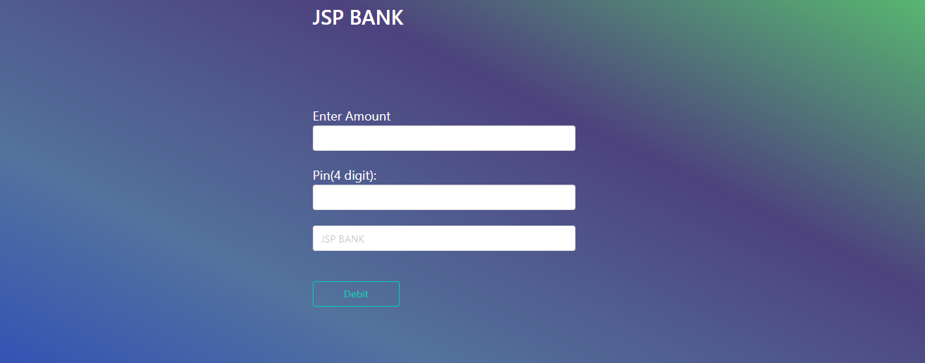

**7.6 USER DEBIT PAGE**

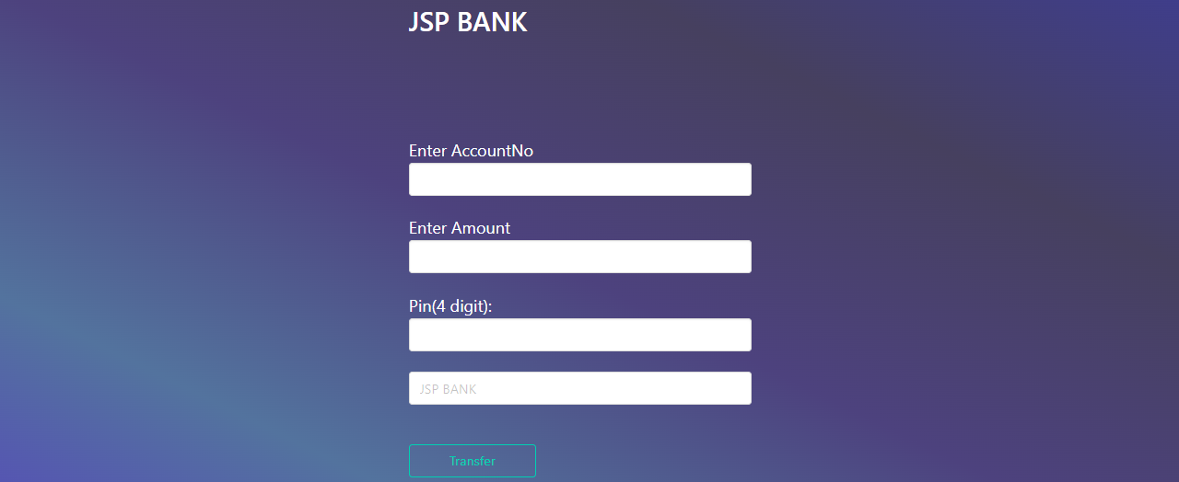

7.8 USER TRANSFER PAGE

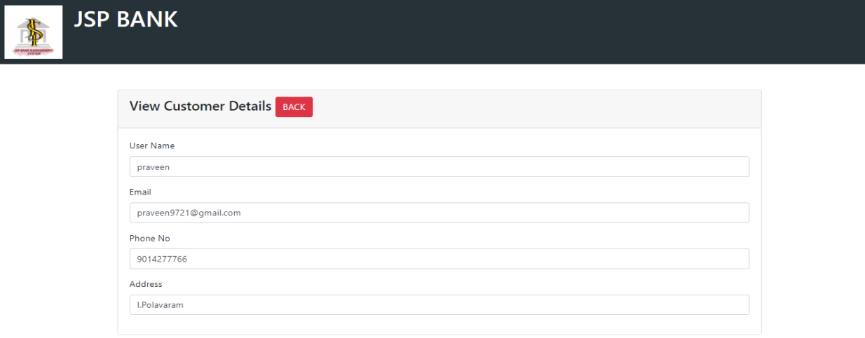

**7.9 CUSTOMER INFORMATION PAGE**

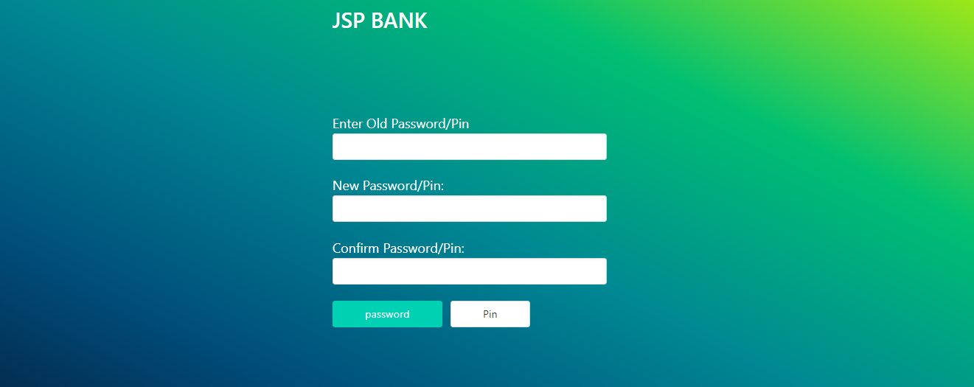

**7.11 USER CHANGE/PIN PASSWORD PAGE**

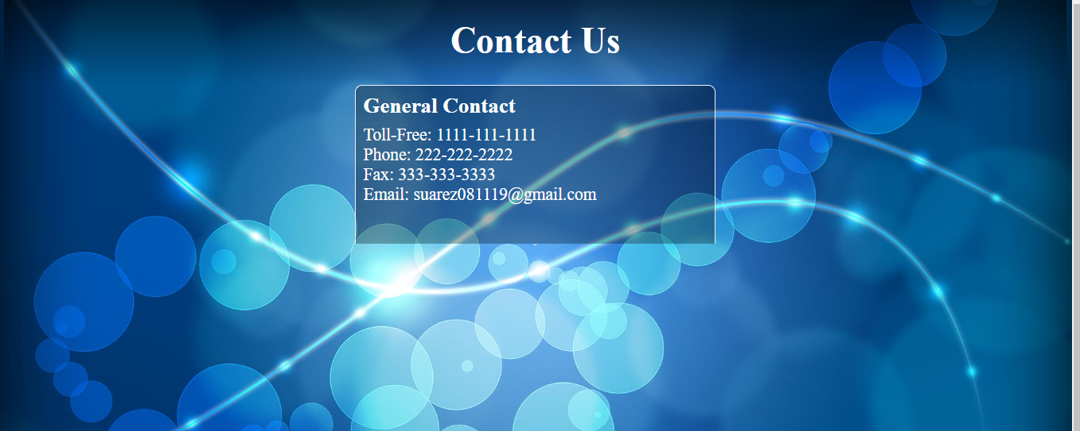

**7.10 CONTACT US**

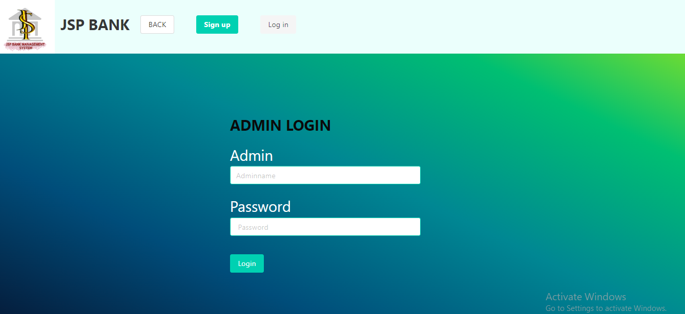

**7.12 ADMIN SIGN-IN PAGE**

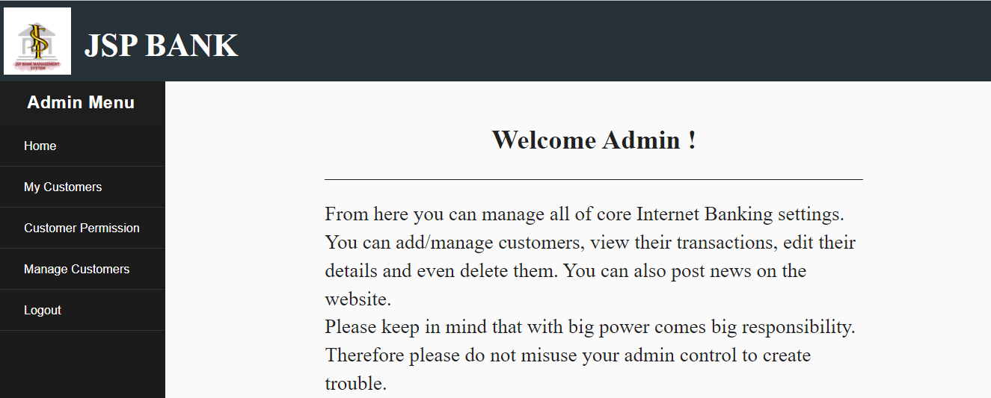

7.13 ADMIN HOME PAGE

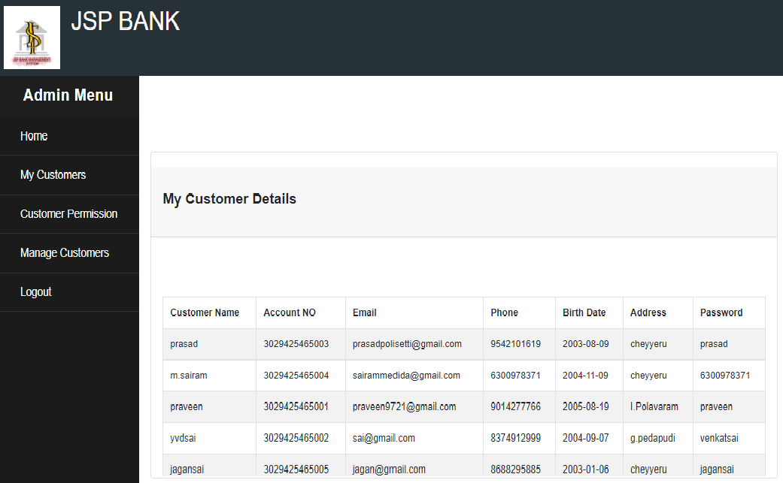

7.15 CUSTOMER DETAILS

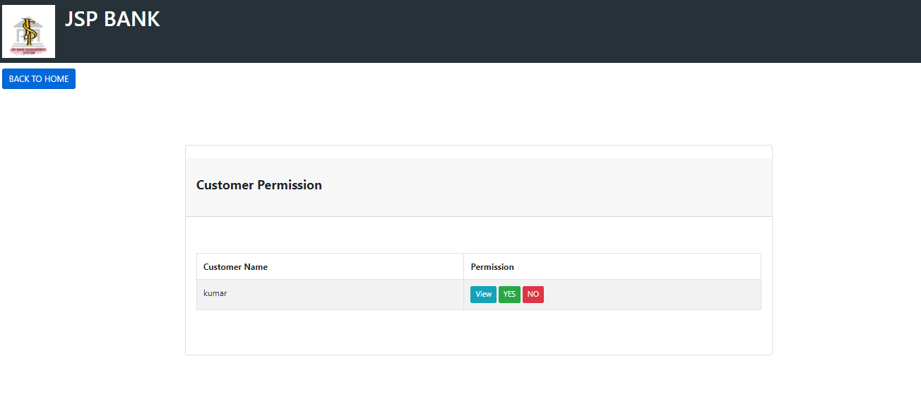

7.14 CUSTOMER PERMISSION PAGE

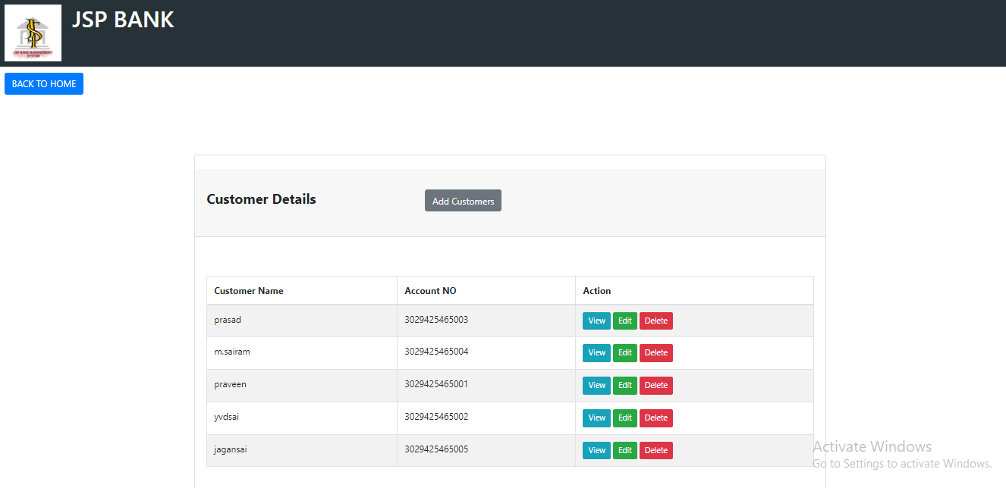

7.16 MANAGE CUSTOMERS PAGE



7.17 CHECK BALANCE PAGE

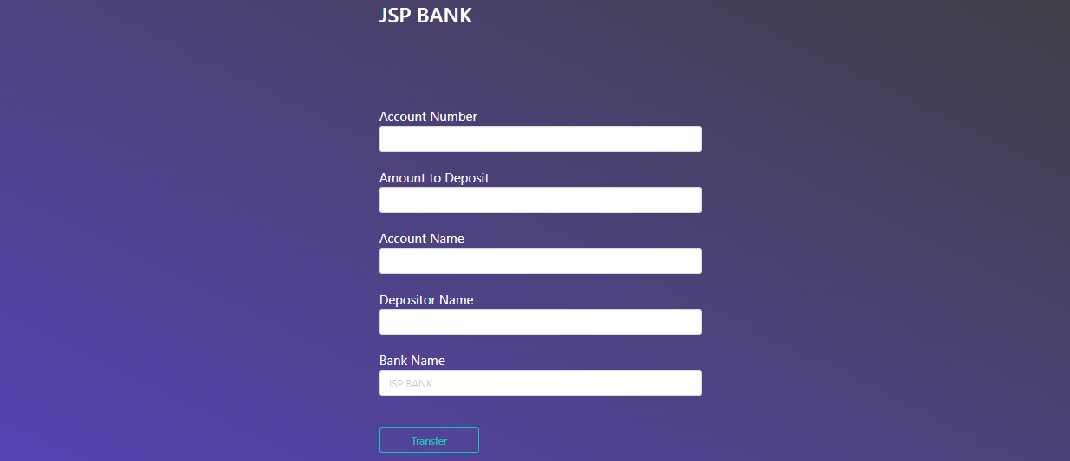

7.18 DEPOSIT PAGE

## CHAPTER - 8 CONCLUSION

Thus, online banking system application provides a very interactive efficient and secure way to put essential financial Information of customer into their account whose account number is known to the customer only. The best important aspect of online bankings is that it's very easy to use and manage financial transaction into the account. It offers loan to bank customer according to customer and keeps information related to it.

## CHAPTER – 9 FUTURE ENHANCEMENTS

The “Banking Online System is a big and ambitious project. I am thankful for being provided this great opportunity to work on it. As already mentioned, this project has gone through extensive research work. On the basis of the research work, we have successfully designed and implemented banking online System. To know what the future of online banking looks like, it’s probably worth looking at the present – online banking isn’t new. When you think of online banking, you probably think about a computer (either a desktop or laptop), a three or four step security process and then an interface that lets you view the balance of your various bank accounts and credit cards, whilst permitting you to transfer money and pay bills. And you’re not wrong either. The most valuable future looks are following below:

* Customer issues development based on their needs, so the help desk will be aware of their needs and easy to use.

* Developing a mobile App for banking system that help users to do the obtained his operations without go to the bank only he need to sign in using his A/C NO. And password and then use your own PIN. Finally the system will update automaticall

* 1. **B:**

## CHAPTER-10

#### BIBLIOGRAPHY

1. 'The Gazetteer of India Volume II - History and Culture', Edited by Dr.P.N.Chopra, Ministry of Education and Social Welfare, 1973.

2. 'Indigenous Banking in Ancient and Medieval India', Brijkishore Bhargave, 1935.

3. 'Commercial Banks in India : Profitability, Growth and Development', Kishore C.Raut & Santosh K.Das, 1996

. 4. 'The Evolution of the State Bank of India', A.K.Bagchi, 1987.

5. 'A Study of the Indian Money Market', Bimal C.Ghose, 1943.

6. Report of the 'Working Group to consider feasibility of introducing MICR/OCR Technology for Cheque Processing', Reserve Bank of India, 1982.

7. Report of the 'Committee on Mechanisation in the Banking Industry', Reserve Bank of India, 1984.

8. Report of the 'Committees on Communication Network for Banks and SWIFT implementation', Reserve Bank of India, 1987.

9. Report of the 'Committee on Computerisation in Banks', Reserve Bank of India, 1988.

10. Report of the 'Committee on Technology Issues relating to Payments System, Cheque Clearing and Securities Settlement in the Banking Industry', Reserve Bank of India, 1994.

11. Report of the 'Committee for proposing Legislation On Electronic Funds Transfer and other Electronic Payments', Reserve Bank of India, 1995.

12. 'Uniform Regulations and Rules for Bankers' Clearing Houses', Reserve Bank of India, 1986. 13. 'Payment Systems in the Group of Ten Countries', Bank for International Settlements, 1993.

14. Reports on Currency and Finance, 1970 - 1997, Reserve Bank of India.

15. Banking Statistics Quarterly Review, 1997, Reserve Bank of India

* 1. **WEBSITES:**

• https://study.com/academy/lesson/banking-system-definition types.html

• https://studybay.com/blog/system-design-of-internet-banking-system/